DEV Board Description and functionality

Description: The MTech EELE Dev Board was developed for the use of teaching embedded systems hardware interface. Mainy features are included namely an interface for I2C and SPI devices (top left), A 7-segment display with four characters (top center), 5V, 3.3V and GND bus (top right), powered servo connections 4x (middle right), USB to UART converter ( middle right), Tri-color LEDs x3 ( middle center), rotary encoder (bottom left), 4x4 Keypad interface (bottom center), programming pins and auxillary pins for the on-board microcontroller (botton center), and a joystick with two axis of freedom (bottom right). The LEDs are all driven by transistors mounted on the back side of the development board. The microcontroller on the back is an MSP430-FR2355 that has access to most of the devices on the front side as will be explained. By default the microcontroller is programmed to have all passive pins but can be programmed to utilize all of the pins as will be outlined.

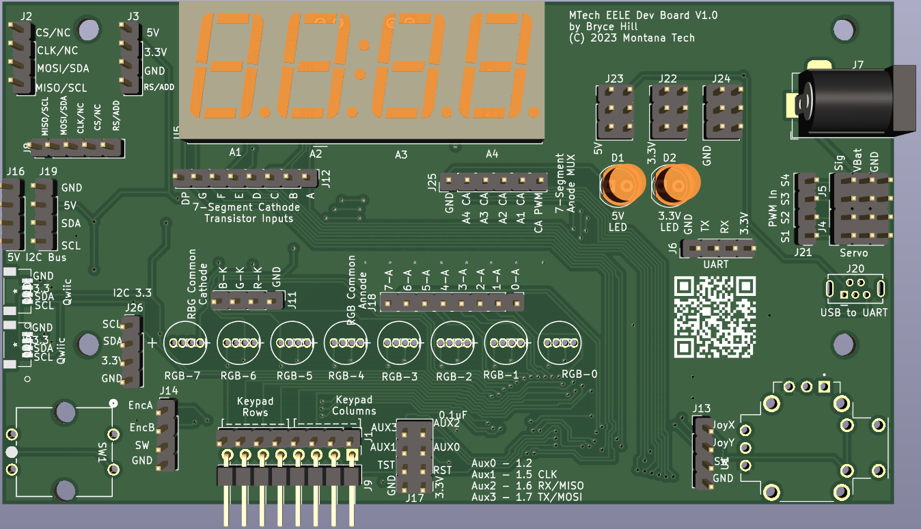

Figure 1: Front of DEV board

I2C and SPI Interface:  
The I2C and SPI interface is specifically developed for boards specific to Montana Tech. These would be an LCD and LED display that dock to the eight pins shown as CS/NC CLK/NC MOSI/SDA, MISO/SCL 5V 3.3V GND RS/ADD. These are internally connected to the five pins directely below them labeled MISO/SCL MOSI/SDA CLK/NC CS/NC RS/ADD. The 3.3 5V and GND pins are all powered directly from the board. There is no direct connection back to the on-board microcontroller.

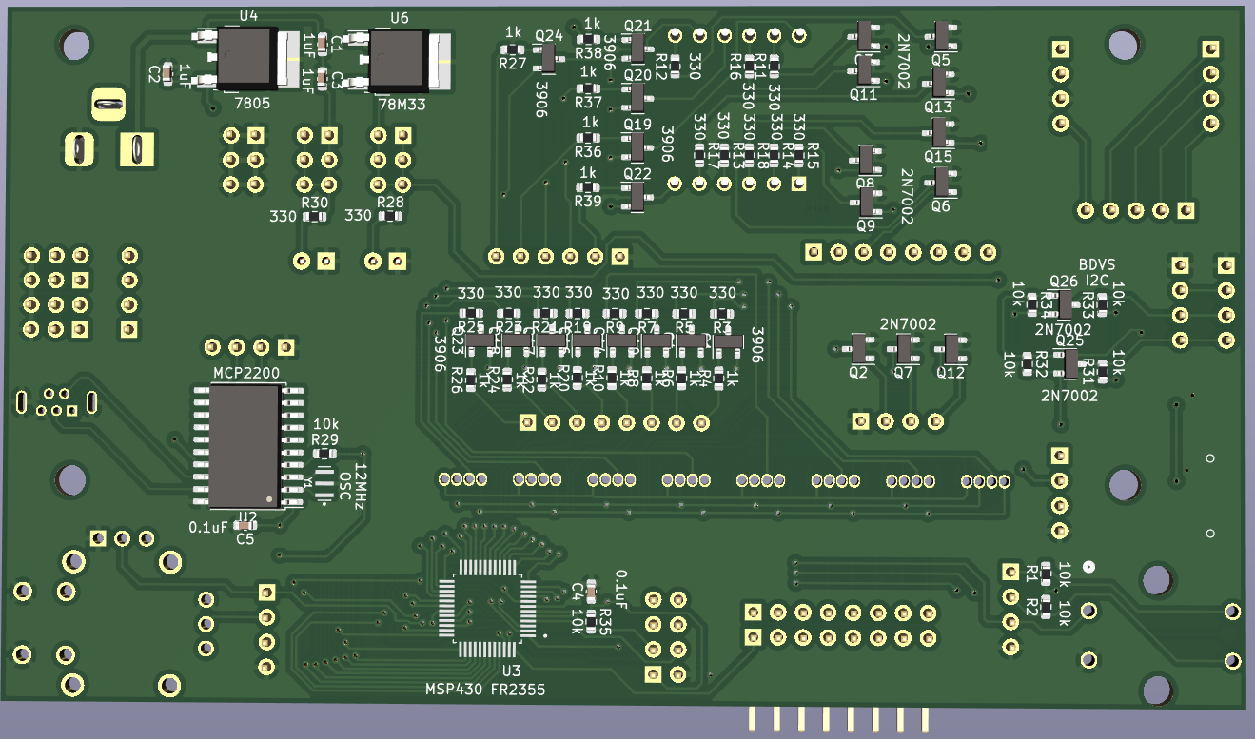

Figure 2: Back of DEV board

7-Segment LED Display:

The 7-segment LED display has four 7-segment displays all of which have a decimal point. The original part is multiplexed so that there are 8 cathodes for each of the 7-segments plus decimal point, and four common anodes for each of the segments. In order to display, the cathodes have to be activated in rapid succession as the anodes are switched to form each of the four characters. Each of the anodes is driven through an PNP transistor with a 1k resistor on the base. A low value to these inputs will activate the anode. There is also an additional anode labeled CA PWM that controls all of the anodes. For any of the segments to light up, that anode transistor must be activated. The 7-segments+DP cathodes are all activated by N-Channel MOSFETs.

All of these cathodes are activated bay a floating N-Channel MOSFETS, a high signal (above 1.8 V) is required to activate them. If they are not connected and left floating they can randomly activate and turn on interesting things randomly. The pins connecting to the gates of these 13 MOSFETS are labeled “7-Segment Cathode Transistor Inputs” and “A4 CA, A3 CA, A2 CA, A1 CA, and CA PWM.” CA stands for Common Anode.

Power BUS:

A power bus is given to you labeled 5V, 3.3V and GND. This simply gives you access to pins that are common to these voltages. Also note the barrel jack labeled J7. Simply power this with a wall adapter with voltage between 7 and 24 V and you will power the entire board. As a warning, this barrel jack is directly connected to the PWM power pins directly below it, so a voltage above the rated voltage for your servo may cook the servo.

There are two voltage regulators that take the input to the barrel jack and regulate that to 5V. The 5V is subsequently regulated to 3.3V.

Powered Servo:

The pins labeled J21 J4 and J5 are a grouping for standard servo connections. The pins labeled VBat and GND are all common to those and tie directly to the barrel jack for power. The Sig pins are connected to the J21 pins directly so you can control each of four powered servo blocks. There is no direct connection back to the on-board microcontroller

USB to UART:

An MCP2200 is the device used for USB to UART. The convert is directly wired to a USB-mini connector on the front side. The MCP2200 connects to pin header J6 for the RX and TX pins, but do not make a direct connection to the on-board microcontroller. The USB port does power the 5V bus directly and the regulator generates the 3.3V power bus as well.

Tri-Color LEDs:

The tri-color LEDs have common anodes and cathodes driven by transistors much like the 7-segment. The LEDs each have a common cathode for each of the three colors, Red, Green, Blue, driven by three N-Channel MOSFETs. A high value for each of the three transistor gates enables the color. These are not designed to be driven high simultaneously, but rather to be multiplexed. The anodes are driven by PNP transistors with a 1k resistor on the base. A low value will activate each of the 8 segments. The anode transistors are directly connected back to the on-board microcontroller to PWM pins of the MSP430-FR2355 so brightness control for each LED and color can be achieved.

I2C Bus (5V):

J16 and J19 are pin headers that are connected back to pins on the on-board microcontroller but the SDA and SCL lines are translated through two bi-directional voltage shifters to 3.3V from 5V.

I2C Bus (3.3V):

Two QWIIC connectors are on the left side of the board. These are semi-standardized connections to the on-board I2C bus but with all pins at 3.3V voltage levels.

Rotary Encoder:

A rotary encoder is on the bottom left corner. This has three connected pins directly back to the on-board microcontroller. Two of the connections are the quadrature rotary signals QA and QB. The third pin is the pushbutton. The pushbutton is floating but connects to ground when pressed. The entire module is powered by 3.3V and generates 0 and 3.3V signals out of the QA and QB outputs labeled EncA and EncB.

Keypad:

The pins for the keypad are two pin headers (J1 and J9) with the pins connected directly to each other and also all eight pins connected to the on-board microcontroller. The double pins is so that the keypad can be tied directly to the DEV board and the pins can be temporarily connected back to any other microcontroller. The pins are labeled rows and columns, but that is subject to how it is connected to the keypad.

Auxiliary pins:

The 2x4 pin header labeled J17 have multiple functions. The bottom four pins are 3.3, GND, TST and RST to program the MSP430-FR2355 via an external programmer. The top four pins are auxiliary pins tied to pins 1.2, 1.5, 1.6, and 1.7. Specifically pins 1.6 and 1.7 are RX and TX pins or MISO, MOSI pins using the USART of the MSP430-FR2355. Pins 1.2 and 1.5 are GPIO pins with some auxiliary capabilities such as I2C SDA, ADC input A2 and A5, SPI MOSI, Clock, TB0TRG, A. See the datasheet for an FR2355. 1.6 and 1.7 were specifically chosen for their usage with the USART namely UCA0 for either SPI or UART TX, RX.

Joystick:

The joystick has two potentiometers built in as well as a push button. The potentiometers are powered with 3.3V and the outputs vary from 0 to 3.3V. The pin header next to the joy stick allows for direct access to the analog values and the pushbutton. The pushbutton is connected to ground when pressed and requires and external pull-up resistor to function properly. All three pins are connected to the on-board microcontroller.

On-board microcontroller:

The on-board microcontroller is a Texas Instruments MSP430-FR2355. It runs on 3.3V and utilizes 3.3V digital logic. The most important information with respect to this microcontroller is which pins are connected to which pieces of hardware on the DEV Board. Below is a list of all pinouts of all pins:

\* 1.0 JoyX

\* 1.1 JoyY

\* 1.2 Aux0 MOSI

\* 1.3 KEY0

\* 1.4 KEY1

\* 1.5 AUX1 SPICLK

\* 1.6 AUX2 UART RX TB0.1

\* 1.7 AUX3 UART TX TB0.2

\*

\* 2.0 Tricolor 6 Annode TB1.1

\* 2.1 Tricolor 7 Anode TB1.2

\* 2.2 KEY2

\* 2.3 KEY3

\* 2.4 ENC Button

\* 2.5 ENCB Input

\* 2.6 ENCA Input

\* 2.7

\*

\* 3.0 7-Segment G Cathode

\* 3.1 7-Segment F Cathode

\* 3.2 7-Segment E Cathode

\* 3.3 7-Segment D Cathode

\* 3.4 7-Segment C Cathode

\* 3.5 7-Segment B Cathode

\* 3.6 7-Segment A Cathode

\* 3.7 7-Segment DP Cathode

\*

\* 4.0 KEY4

\* 4.1 KEY5

\* 4.2 KEY6

\* 4.3 KEY7

\* 4.4 Tri-Color Red RGB FET

\* 4.5 Tri-Color G RGB FET

\* 4.6 SDA

\* 4.7 SCL

\*

\* 5.0 7-Segment PWM control TB2.1

\* 5.1 7-Segment Digit 1 Anode

\* 5.2 7-Segment Digit 2 Anode

\* 5.3 7-Segment Digit 3 Anode

\* 5.4 7-Segment Digit 4 Anode

\*

\*

\* 6.0 TriColor 0 Annode TB3.1

\* 6.1 TriColor 1 Annode TB3.2

\* 6.2 TriColor 2 Annode TB3.3

\* 6.3 TriColor 3 Annode TB3.4

\* 6.4 TriColor 4 Annode TB3.5

\* 6.5 TriColor 5 Annode TB3.6

\* 6.6 TriColor Blue RGB FET

\*

For reference, the physical pictures of a board are shown below.

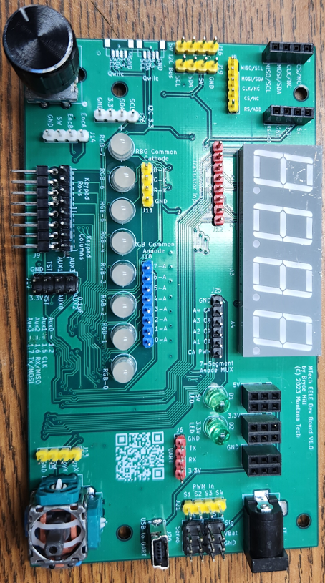

Figure 3: Front of DEV Board

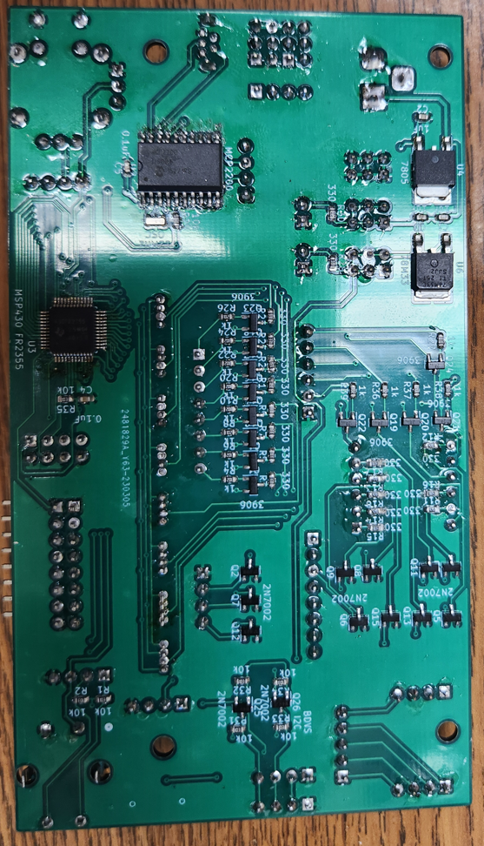

Figure 4: Back of Dev Board